Assignment Sheet 

Assignment 1 :- How to upload HTML web pages on Apache2 web server in EC-2 Instance? Please justify with step by step answers.

Steps to host HTTP page

For Inbound

* Go to EC2 Dashboard ->security ->security groups
* Click on inbound rules
* Edit inbound rules
* Add new rules ->Type http & source 0.0.0.0/0
* Save rules

For outbound

* Go to EC2 Dashboard ->security ->security groups
* Click on Outbound rules
* Edit Outbound rules
* Add new rules ->Type http & source 0.0.0.0/0
* Save rules

Now copy the public IP of the instance and paste it to a new tab

Assignment 2 : Create readfile.sh in which you can read the information of PWD like size, permission, date time etc.

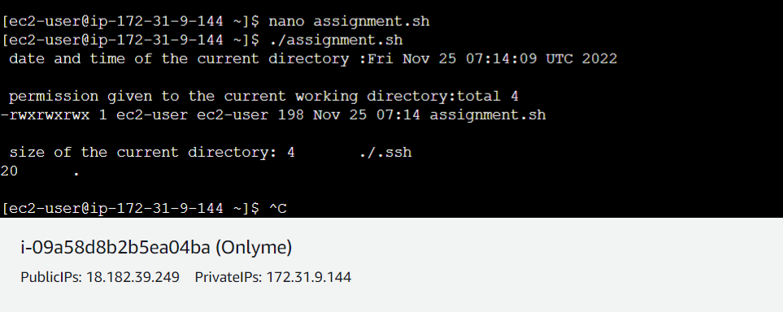

Assignment 3 : Take an input of name from user and print Have a great day ahead {name}

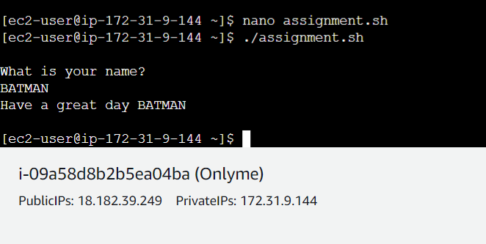

Assignment 4 : Let’s take a scenario of fintech app program in which we want to have three separate outputs for 3 different situations:

→The balance is less than zero

→The balance is zero

➔ The balance is above zero

For instance, in the following program, use the if, elif, else statements to display different outputs in different scenarios:

Use “if” condition to check if the balance is less than zero. If this condition evaluates to true, display the message using the echo command: “Balance is less than zero, Please add more funds else you will be charged penalty”.

If the above condition does not match, then use “elif” condition to check if the balance is equal to zero. If it evaluates to true, display the message: Balance is zero, please add funds

If none of the above condition matches, use the “else” condition to display the: Your balance is above zero.

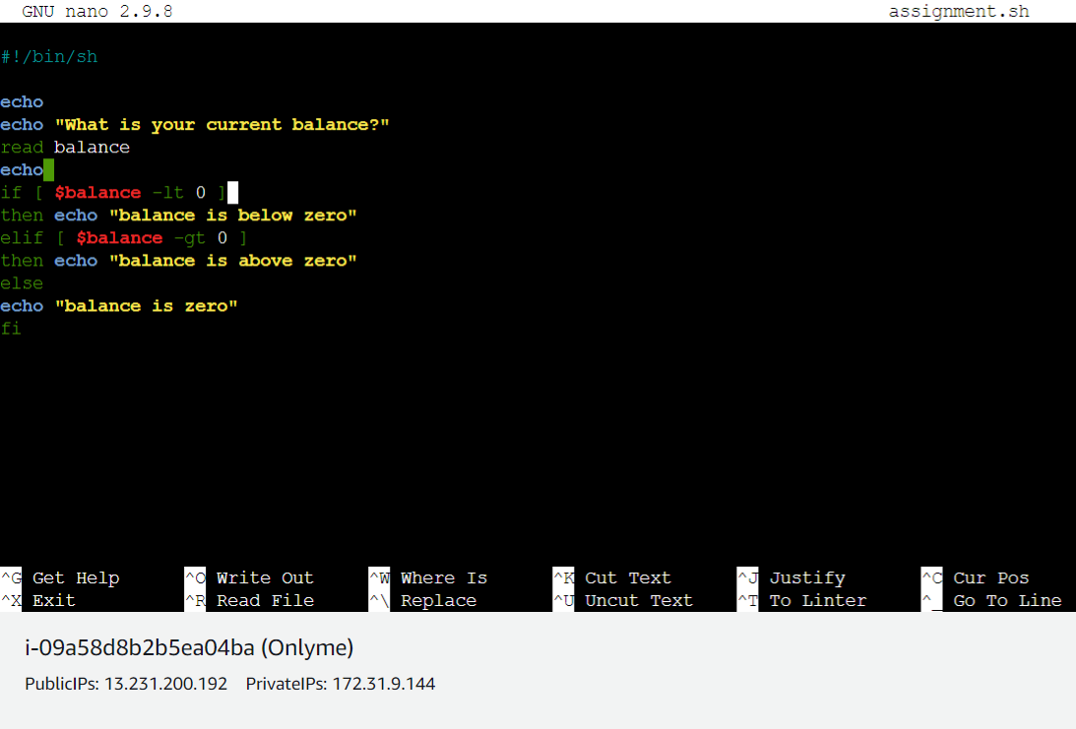

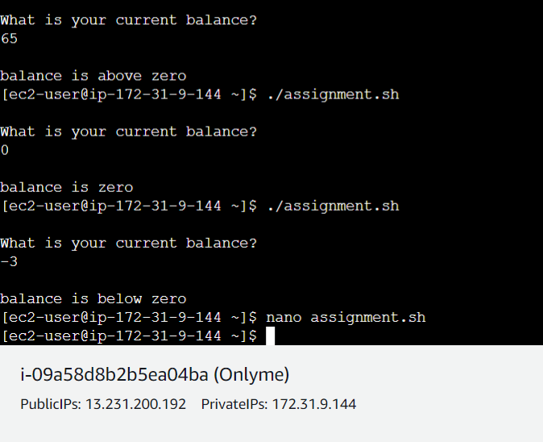

Assignment 5 : Debug and define briefly about

the following program:- #!/bin/bash

# Print a message about disk usage

space_free=$( df -h | awk '{ print $5 }' | sort -n | tail -n 1 | sed 's/%//' ) case $space_free in

[1-5]*)

echo Plenty of disk space available

[6-7]*)

echo There could be a problem in the near future

8*)

echo Maybe we should look at clearing out old files

9*)

echo We could have a serious problem on our hands soon

*)

echo Something is not quite right here

;;

Esac

